

C0618 MRB Custom RMB – Business Requirement Specification

This document has been approved by

|  |  |
| --- | --- |
|  |  |
| Business consultant | Solution owner or accountable role |
|  |  |
| Date | Date |

Document Revision History

|  |  |  |  |
| --- | --- | --- | --- |
| Revision | Date | Author | Remarks |
| A1 | 2021-04-13 | BTIMBERLAKE | First Revision |
| A2 | 2021-05-06 | BTIMBERLAKE | Revisions made to section 4.3 MRB Object Connection |
|  |  |  |  |
|  |  |  |  |
|  |  |  |  |
|  |  |  |  |

Table of Contents

1 Purpose and Guideance 4

2 Open Issues/Decisions Required 5

3 Business Requirements and References 6

3.1 Business Requirements 6

3.2 Sources and Dependencies 6

4 Solution Description 7

4.1 Process Description 7

4.2 NCR Creation Data Mapping 8

4.3 MRB Object Connection 9

5 Delimitations 10

6 Glossary/Acronyms 11

7 Change log 12

7.1 Change log for revision XX 12

# Purpose and Guideance

There is a requirement for EDI to allow exchange of messages with suppliers for Purchase orders and purchase order management through to invoicing. This increases efficiency in order processing and supply chain management and ensures accuracy of data on both systems and guarantees the timely receipt and processing of the purchase order by the supplier. This is also essential to the full supply chain as forecasting will be includes as well as purchase orders. In preparation for go live it will also reduce the requirement for supplier specific reports.

# Open Issues/Decisions Required

This specification cannot be completed until the following issues/decisions have been resolved:

|  |  |
| --- | --- |
| Issue/Decision | Responsible |
|  |  |
|  |  |

# Business Requirements and References

## Business Requirements

Tunstall recognize the benefits of using the MRB process to inspect materials and identify where the buyers and/or quality team need to interact with suppliers around issues found either upon arrival or when in inventory.

What is also noted is that in creating the NCR after the MRB is processed appears to bring with it a large amount of duplication around data and information input. Here Tunstall require a way to have the information from the MRB to automatically transfer to the NCR upon creation.

## Sources and Dependencies

|  |  |  |
| --- | --- | --- |
| Case, Document or Customization ID | Title or Description | Comments |
|  |  |  |
|  |  |  |

# Solution Description

## Process Description

Tunstall require a custom right mouse button (RMB) on the MRB Case screen (Logical Unit: MrbHead) that they can action to create an NCR automatically. This RMB needs to take data from the MRB screen, combine it with some hardcoded data and create a brand-new NCR. It also then needs to attach the MRB to the NCR as an object.

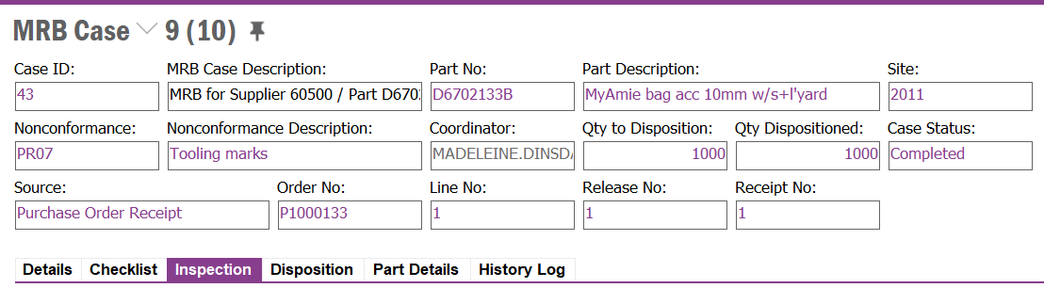

To do this the below mappings have been detailed which incorporate the mandatory and commonly used fields on the NCR screen when creating a new record. These are also the fields that can be/are required to be completed via the Create NCR Assistant screen. The solution is to skip this manual raising process by having the custom RMB do this for the user.

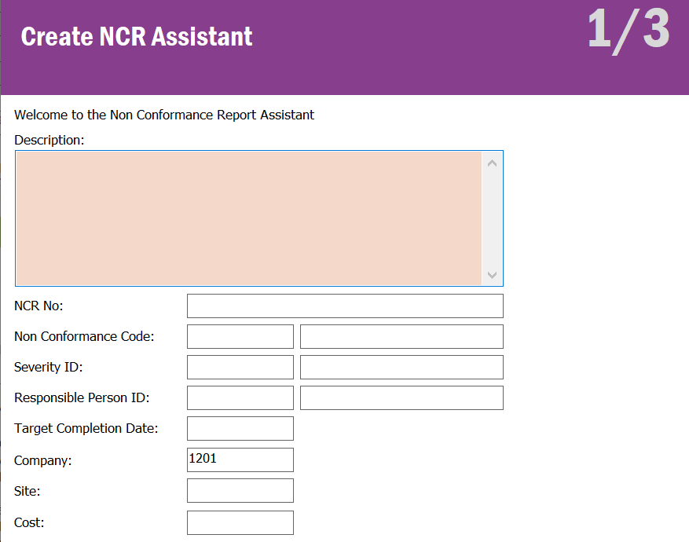

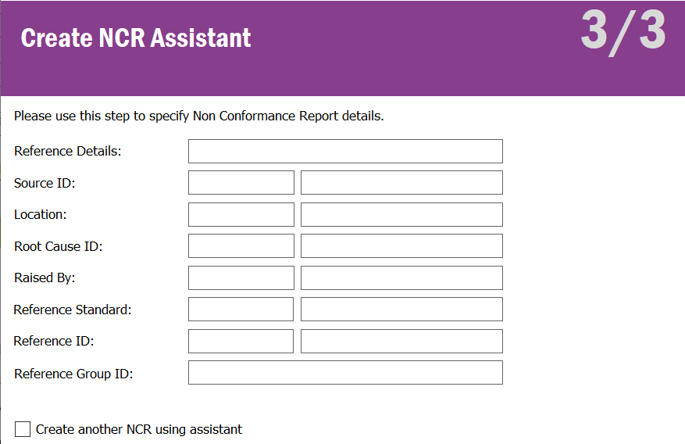

## NCR Creation Data Mapping

Below shows the NCR fields that require populating from the custom RMB. Some of these are mapped with data sources on the MRB, others are hardcoded inside the RMB event.

|  |  |  |  |
| --- | --- | --- | --- |
| NCR Field  (Field on NCR Creation)  NON_CONFORMANCE_REPORT | Source  MRB Field / Hardcoded | Source  Logical Unit | NCR Data Type  (Data Type on NCR Creation) |
| DESCRIPTION | MRB_DESCRIPTION | MRB_HEAD | STRING(500) |
| NCR_NO | *Follow IFS logic and allow the NCR to generate next NCR No automatically* | | |
| NONCONFORMANCE_CODE | MRB_CODE | MRB_HEAD | STRING(25)/UPPERCASE |
| SEVERITY_ID | 20 (Medium Severity) | HARDCODED | STRING(25)/UPPERCASE |
| RESPONSIBLE_PERSON_ID | MRB_COORDINATOR | MRB_HEAD | STRING(20)/UPPERCASE |
| TARGET_COMPLETION_DATE | SYSDATE + 21 Days | HARDCODED | DATE/DATE |
| COMPANY | 1201 | HARDCODED | STRING(20)/UPPERCASE |
| CONTRACT | CONTRACT | MRB_HEAD | STRING(5)/UPPERCASE |
| NCR_REFERENCE_DETAILS | CF$_SUPPLIER_NO | MRB_HEAD_CFV | STRING(20)/UPPERCASE |
| RAISED_BY | MRB_COORDINATOR | MRB_HEAD | STRING(20)/UPPERCASE |

## MRB Object Connection

The Final steps are to have the MRB and associated Supplier added as objects to the created NCR via the Connected To tab on the Non-Conformance Report screen. The first Object needs to be the MRB Head and the MRB Case needs to be the MRB Case number that the RMB was actioned on. The second Object needs to be Supplier Info General and the Supplier ID needs to be the item referenced in the NCR_REFERENCE_DETAILS field on the NON_CONFORMANCE_REPORT Logical Unit (see 4.2 NCR Creation Data Mapping section).

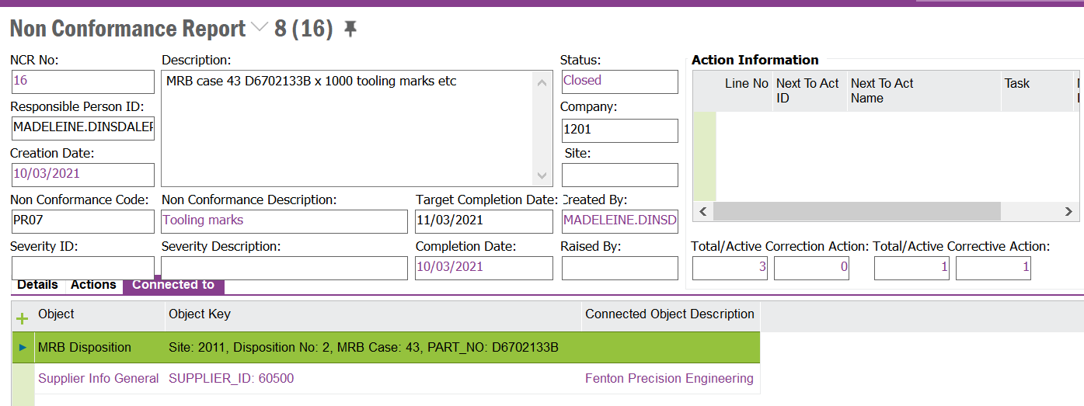

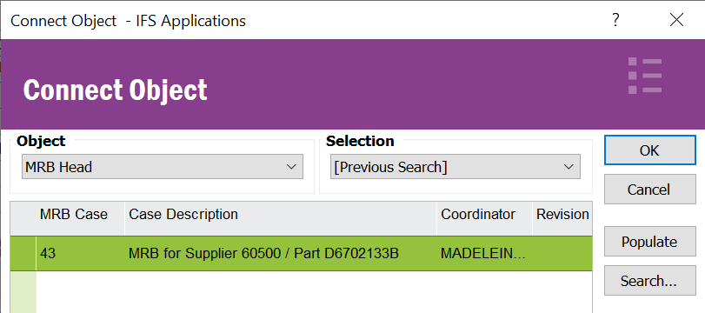

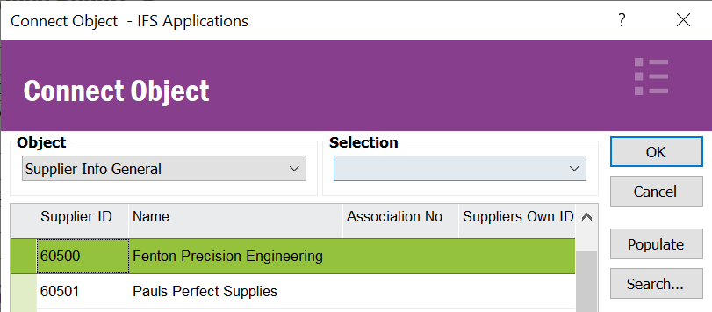

# Delimitations

The modification in this specification will be developed explicitly as written. Requests for changes in the modification necessary to fulfil (or prepare for future fulfilment of) any requirements not explicitly described in the specification, will be considered outside the scope of this modification.

Changes or extensions on Online Help (F1 Help) or e-learning material will not be included.

# Glossary/Acronyms

Commonly used IFS terms within this specification include:

|  |  |
| --- | --- |
| Term | Explanation |
| LOV | List of Values. This refers to a source list of records from which to select in a form. |
| RMB | Right Mouse Button. Commonly used abbreviation |
|  |  |

# Change log

Guidance: Delete section if no changes

## Change log for revision XX

Guidance: Describe why the change is needed (high level), and the sections of design affected by the changes. For lengthy specs, tag or mark the changed sections.

|  |  |  |
| --- | --- | --- |
| Change # | Chapter | Description of the change |
| 1 |  |  |
| 2 |  |  |
| 3 |  |  |
|  |  |  |
| n | 3.2 | <New column Z added to existing window> |

##### Detailed description of Change #1

##### Detailed description of Change #n

# DELIVERY NOTES

**Package** - EA_SUPPLYCHAIN

**Permissions granted** – IFS_ALL

**Custom Menu**

If the menu is not available in the window, RMB, custom Objects, Reload configurations.

